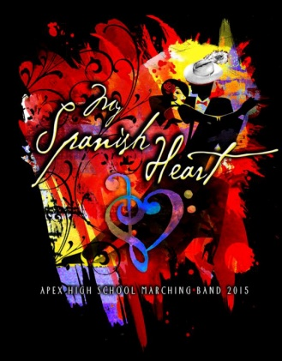
Annual Marching Band Banquet
Thursday, April 14 6:00 pm until 9:00 pm
Apex United Methodist Church, 100 S Hughes St., Apex

My Spanish Heart
All band members and their families are invited to attend.
(There is no cost for Marching Band Members - but they still must RSVP).
Dinner is catered by Daniel’s Restaurant and includes full meal and dessert.
Cost for family members is $12_ per person.
Children 10 and under have a reduced cost of $6 per person.
RSVP is required for anyone attending dinner.

Dinner Begins at 6:00pm sharp, Band Awards &
Booster Board Business Immediately Follow

*NEW THIS YEAR* we're offering a video compilation on both DVD and HD digital copy. DVDs are great, but they're "standard def" which is only 480 resolution. The source was shot in HiDef (720 or 1080). If you'd like the hi def copy of the content here is what you can do:
- include a 16 GB (or larger) USB stick or SD card with your order form
- make sure it's empty and formatted for either FAT32 or HFS (Mac OS X). If that's Greek to you just make sure it's empty and we'll take care of the rest
- put it in an envelope along with this form and a check to "Apex Band Boosters", and place in the order envelope in the band room (Please put your student’s LAST name on the USB stick)

All preordered DVDs/USB Sticks will be available for distribution at the banquet.

Please make checks payable to Apex Band Boosters:
Complete & Return the bottom portion of this form along with your payment by
Wednesday March 23rd, 2016.
Please use the Large Collection Envelope Designated in the Band Room.

If you have any questions about the banquet or have special dietary needs please contact
Linda Brothers – social@apexhighband.org

Band Student: ______________________________ # of Family Members Attending: ________
(Note: Please print names of family members attending below, use back of sheet for additional names)

1._________________________ 2.__________________________

3._________________________ 4.__________________________

BAND STUDENT (S)……………………………………………………………………………………………………………..$ FREE
TOTAL FOR MEALS at $12 EACH ……………………………………………………………………………….………$ _____________
TOTAL FOR kids (10 and under) at $6 EACH ……………………………………………….……………………$
Include additional $10 for the season recorded on DVD ……………………………….…………………$
Include additional $10 for the season recorded on USB (hi Def)………………….………………….$
If you want Both DVD and USB (include just one fee of $15)……………………….…………………$

TOTAL AMOUNT ENCLOSED (no cash please, checks payable to Apex Band Boosters: $______________

In case we have any questions for you, please include best way to contact you:
E-mail address __________________________ & Phone #________________

SUNDAY BEST ATTIRE REQUESTED
Student accounts may not be used to purchase family/guest meals or the dvd.
Please No Cash ~ Make Checks Payable to: Apex Band Boosters, please include student name in memo of check.
Checks Returned for NSF will incur a bank fee as imposed to the boosters.
Please return this portion of the BANQUET RSVP (with PAYMENT of applicable) no later than March 23rd.

