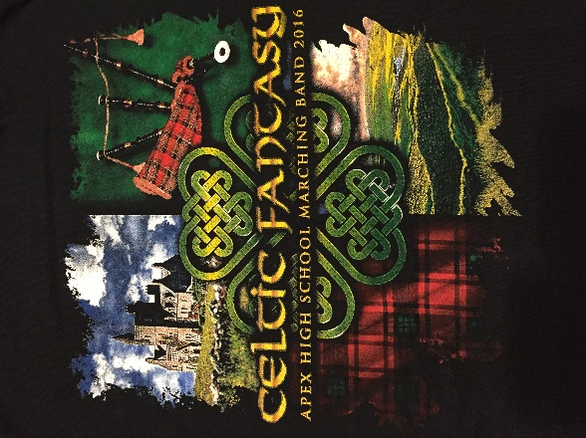
Celtic Fantasy
The Annual Apex High School Marching Band Banquet
Friday, April 28, 2017
6:00 PM to 9:00 PM
Apex United Methodist Church
100 South Hughes Street, Apex

All marching band members and their families are invited to attend
Sunday Best Attire Requested
Dinner will begin promptly at 6:00 PM
Booster Board Business and Band Awards Immediately Follow

Dinner is catered by Daniel’s Restaurant
The menu includes:
Garden Salad
Grilled Vegetable Platter
Penne a la Casa (vegetarian)*
Chicken Piccata*
Foccacia Bread
Brownettes and Cannoli
Iced Tea- Sweet and Unsweet
*Gluten free and dairy free options available upon request.
Cost:
No cost for marching band member.
Family members $15.00 per person
Children 10 and under $7.00 per
An RSVP is required for anyone attending the dinner.
Complete and return the bottom portion of this form along with your payment by Friday, April 7, 2017.

Please print names of student and family members below. Use back of sheet for additional names.
Payments can be placed in the Band Banquet envelope in the Band Room.

Band Student: __________________________ Family Member 1: _______________________

Family Member 2: _______________________ Family Member 3: _______________________
Please indicate special meal request: Gluten Free Dairy Free
Band Student(s)…………………………………………………………………………$Free
Total for Adult Meals $15.00 each……………………………………………..$________________
Total for Child Meals $7.00 each………………………………………………..$________________
Total amount enclosed ………………………………………………………………$________________
Please make checks payable to Apex Band Boosters. No cash please.
This year we are pleased to offer online payments via your Apex Marching Band Charms Account. You can make your purchase in the Charms Store.
For information and questions, please contact Cindy Giambusso at cpgiambusso@yahoo.com

